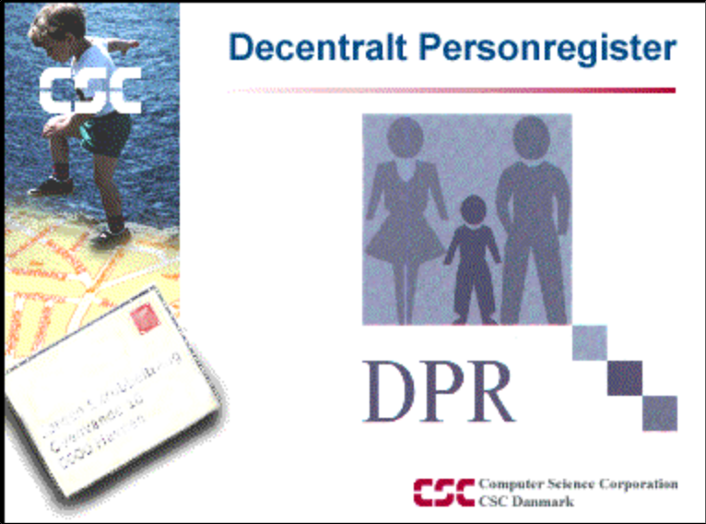

DPR Viderestilling

Installations- og driftsvejledning

Introduction
DPR Diversion shall be installed and run on a Windows platform. There must be a TCP / IP connection to the client applications as well as CPR Direct client .. Moreover, there must be an ODBC connection to the DPR database, which can either run on the same server or on another server.

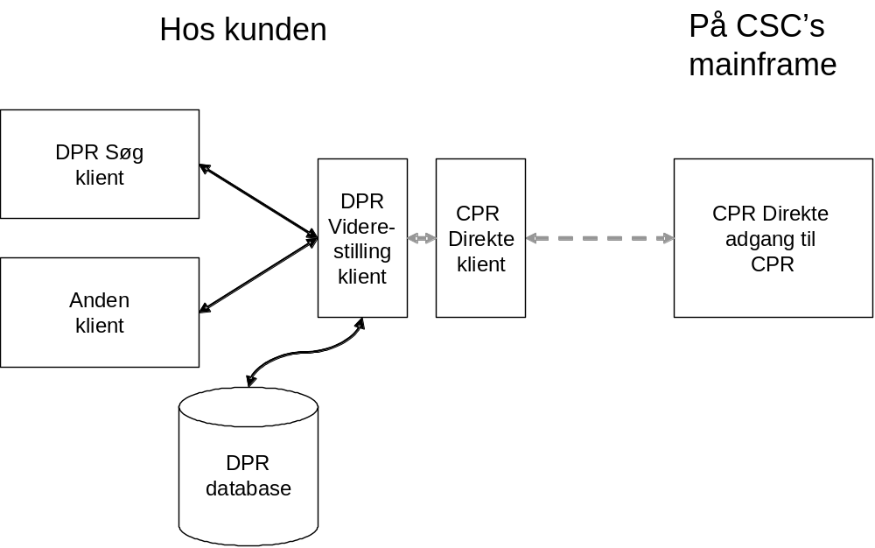
Figure1. Configuration Drawing for DPR Diversion.
Ingredients
Product DPR Diversion consists of the following files:
DPRvidere.exeThe DPR Diversion Program.
DPR_videre_log.txtText file, which DPR Continuation of post-dialing logged.
DPRvidereSetup.msiFor installation of the DPR Diversion Program and
related services
The program requires that . NET Framework is installed on your machine. That is the standard basis with the later versions of Windows operating systems.
Furthermore, a product of this installation and operating instructions and directionsDPR Diversion. Interface for client application.
Installation and setup
Installing the program files
Installation is usually of the CSC. The delivered files are copied instance in a folder on DPR server where the other DPR server programs exist.
First install DPR Diversion Program and related services by running
DPRvidereSetup.msi.
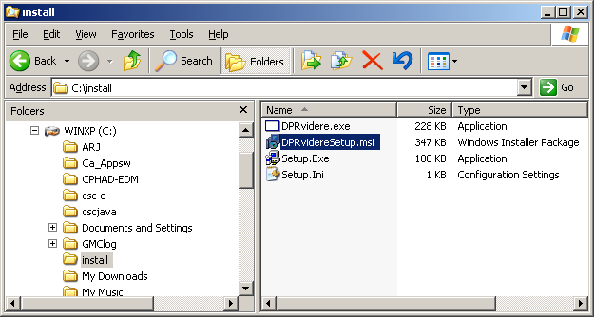
Figure2. They received DPR Diversion files.

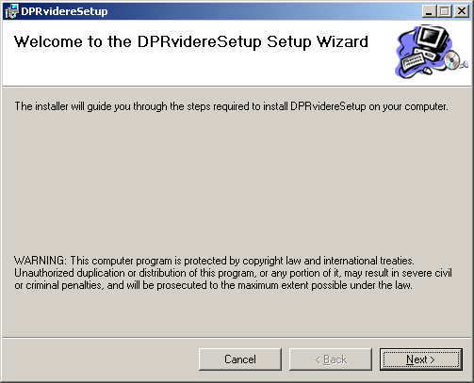
Figure3. Welcome picture for installation.

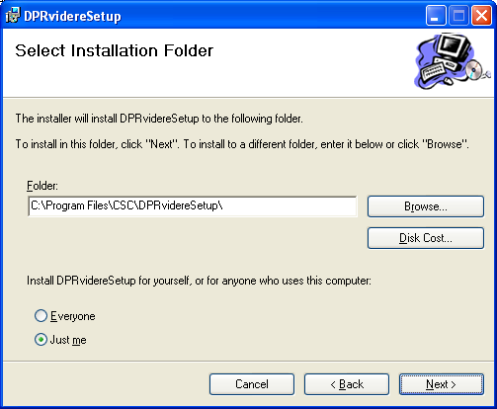
Figure4. Choose the folder DPR Diversion must be installed in.
Specify the user to run the service. This can be changed later via the Windows Services window. Must specify machine name \ username.
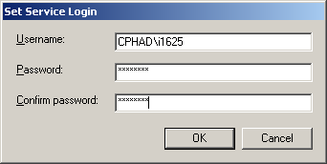
Figure5. Example of indication of the user.
In the subsequent graph displays example of failed installation when Username / Password is not specified correctly.

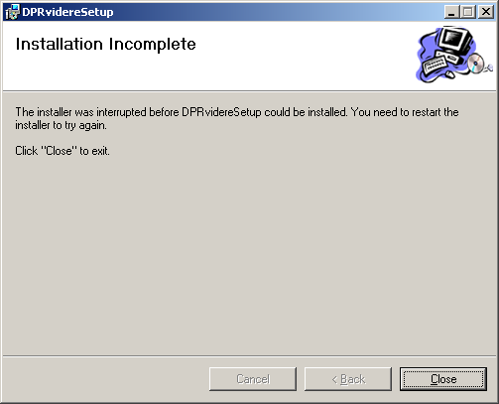
Figure6. Error message at the wrong Username / Password.
When everything has gone well, one can in Windows Services window see the new service.

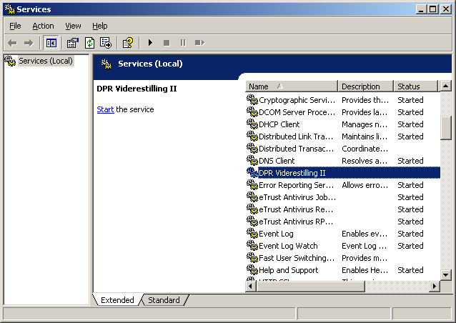
Figure7. You will now see the new DPR Diversion service of the statement.
The above services window displays, select Start - Control Panel - Administrative Tools - Services.
It is recommended that the following window change from "This account" to "Local System account".
Right also possible boot method (automatic / manual).
Hold onto start the service.

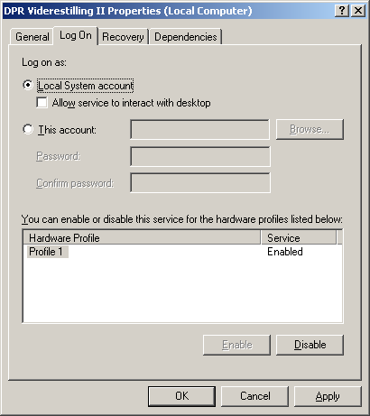
Figure8. Window to indicate the properties of DPR Diversion.
Now copy the DPR Diversion Program (DPRvidere.exe) to the same folder as the service was installed in. In this example it will say in c: \ program files \ CSC \ DPRvidereSetup \,
Customizing the configuration of the DPR Diversion
Start Program DPRvidere.exe.
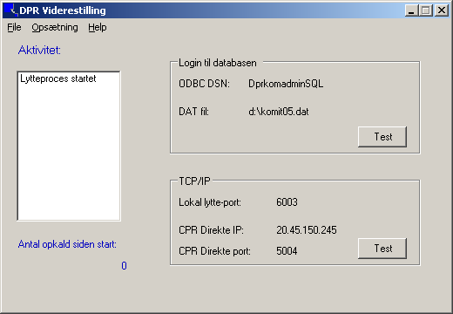
Figure9. Start Picture DPR Diversion.
The program ends by choosing File - Exit.
Before the program can be used there should be a setup of parameters.
If some of the required parameters is missing, the program will automatically display images to enter it.
Setting up database access
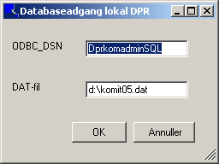
Figure10. Setting up database access.
Under "ODBC_DSN" must specify the ODBC data source used to achieve the DPR database.
Under "DAT File" is to be the location and name of the. DAT file specified. DAT file contains encrypted User-ID/Password for database access.
Configuring TCP / IP
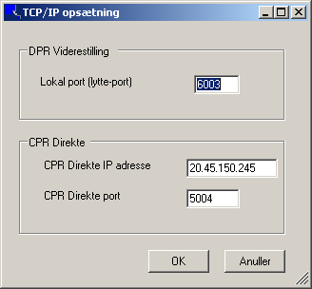
Figure11. Configuring TCP / IP parameters.
Under "Local port (listening port), indicate the port that DPR Diversion listen on when to receive calls from DPR Search or other clients.
Under "CPR.Direkte IP address" indicates the IP address of the machine where CPR Direct up.
Under "CPR Direct Port" specifies the port number that CPR Direct Client listens on. See the configuration of CPR Direct Client.
Configure logging
Certain events can be logged.
Under Settings - Turn logging on / off, you can choose whether logging is required.
The log created by DPR Diversion in the root of the system drive, usually c: \.
Uninstalling the DPR Diversion.
Go in the usual manner under Start - Control Panel - Add / Remove Programs and select DPRvidereSetup.
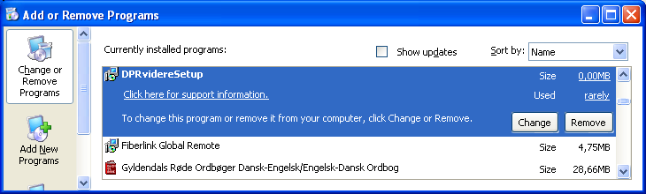
Figure12. Uninstalling the DPR Diversion.
Customizing the setup of CPR Direct
CPR Directly ordered from CPR office. When ordering the product received a guide in setting up the included client.
Customizing the registry DPR Search
If DPR Find used as a client application must LU62MODE set to ON in the registry under [HKEY_LOCAL_MACHINE \ SOFTWARE \ CSC Danmark A / S \ DPR for Windows].
In addition, the IP address and port number of DPR Forward Ling Program at DPR server specified.
Finally, set a value for the timeout.
The lines in the registry can for example look like:
[HKEY_LOCAL_MACHINE \ SOFTWARE \ CSC Danmark A / S \ DPR for Windows]

Value in the Registry | Explanation
"LU62MODE" = "ON" | "ON" means that DPR Search client knows that DPR forwarding is available. ¤
"DPRV_IP" = "123.45.67.89" | The IP address of the machine where DPR Diversion settled.
"DPRV_Port" = "700" | This is the port number that DPR Diversion listening to. See the configuration of DPR Diversion.
"DPRV_TimeOut" = "30" | Is the time in seconds that the DPR Search awaiting answers from DPR Diversion.
Table1. Configure the registry.
Test
When installing the DPR Diversion is completed, a test.
There is scope for testing the connection to the DPR database. Click the Test button under "Login to the database."
Click "Test" button.
If the connection is OK the following window.
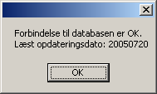
Figure13. Answer Window at the test against DPR database.
Update date is of course dependent on the facts of the DPR database.

There is also scope for testing the connection to the CPR Direct. Click the Test button under the TCP / IP.
Click "Test" button.
If the connection is OK the following window.
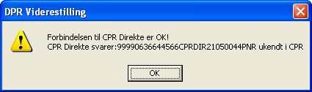
Figure14. Answer Window at the test against CPR Direct.
Operating
DPR Diversion Program DPRvidere.exe can either run as a regular program with a visual interface or as a Windows service, which the program is not visible and otherwise up-and closed automatically with the machine.
Proceedings of the DPR as commonly Diversion Program
The former option is used in the configuration / modification of the driving parameters.
The program is started for example. by double clicking on it via Explorer.
Proceedings of the DPR Diversion as Windows Service
- Close possibly ride version of the DPR forwarding.
- Start the service using Windows Services window. Select Start - Control Panel - Administrative Tools - Services.
- Right click on the "DPR Diversion II" and select "Start."
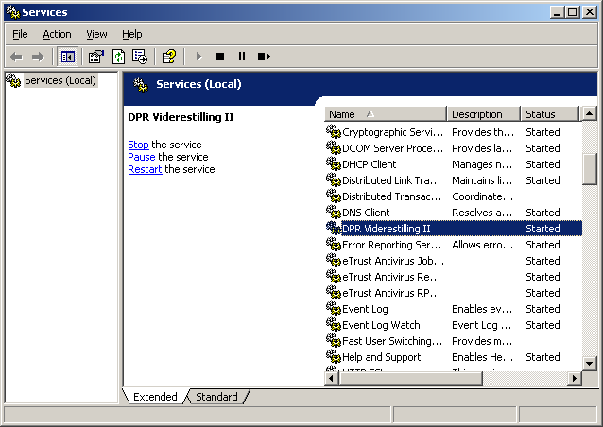
Figure15. Services window.

Logging of events
A number of incidents, including some error types are logged, if logging is turned on.
DPR Diversion log events in the file dpr_videre_log.txt.

01-09-2005 21:08:42 | Services has stopped
01-09-2005 21:09:01 | Service started
01-09-2005 21:09:02 | *************************************** ****
01-09-2005 21:09:02 | ****** Starts: DPR Diversion
01-09-2005 21:09:02 | ****** Version: 1.0.0.2
01-09-2005 21:09:02 | ****** Inquiry into CPR from local DPR system
01-09-2005 21:09:02 | *************************************** ****
01-09-2005 21:13:19 | Services has stopped
Example of the log.

The service also logs certain things in the Windows Event Log under the Application Log.
Select Start - Control Panel - Administrative Tools - Event Viewer - Application.

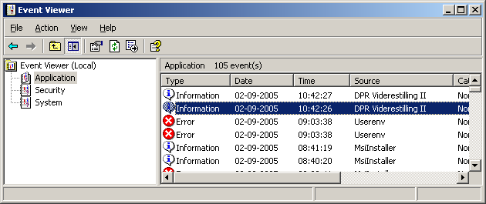
Figure16. Windows Event Log.

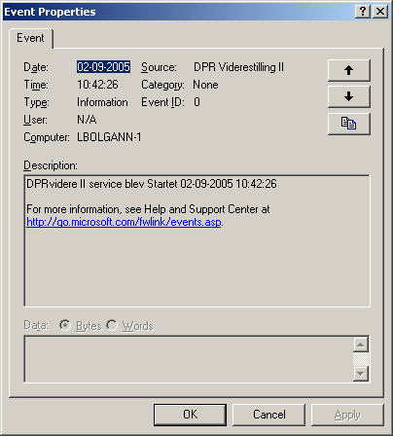
Figure17. Description of the selected event (Event).
DPR Search
When DPR Diversion is installed, users of DPR Search option to retrieve information on persons who do not already exist in the DPR database. Furthermore, the ability to retrieve current information on people in the DPR database marked "U" too uncertain address.
New people
When a user finds on a number of a person who is not found in the DPR file is automatically sent a call out to the CPR system. CPR system returned the information about name, address, status and possible. protection. This information is presented to the user in the window.

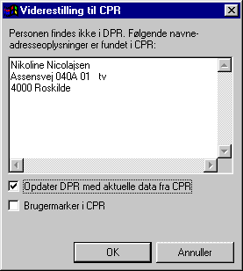
Figure18. Window for retrieving new data.
You now have three options:
- Just see the displayed data and select "Cancel." This there is neither a storage place in the DPR and a user selection in CPR.
- Put checkmark in the "Update DPR with current data from the CPR" but not in the "User Mark in CPR." This will retrieve the current data for the person in CPR and they entered into the DPR database. Since no ordered update from CPR, there will be a so-called U-marker in the DPR.
- Put checkmark in the "Update DPR with current data from the CPR" and "User Mark in CPR." This will retrieve the current data for the person in CPR and they entered into the DPR database. In addition to having a user selection in CPR, so that the information on the person will be updated from the CPR with the daily change drawer.
Update U-selected individuals
If a person is moved from the municipality / county or otherwise no longer be updated from the CPR, this is the DPR database marked with a "U" in the field TFDTOMRK in DTTOTAL. In DPR search is shown that U in the box to the right of "Address Date."
When a person is U-selected, activated command features - CPR Lookup. When this command is selected, given the same opportunity to obtain current data as for those not already exist in the DPR database.
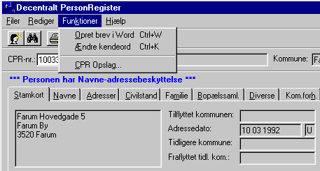
Figure19. CPR posters for U-selected individuals.

